**SQL ASSIGNMENT**

**CustomerHeader Table**

**Queries Screenshot**

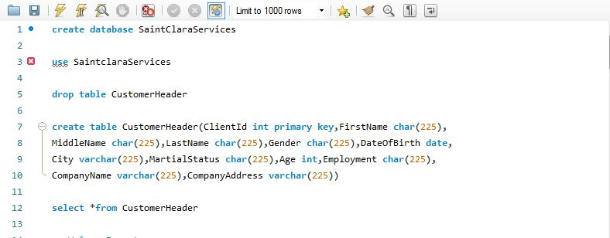

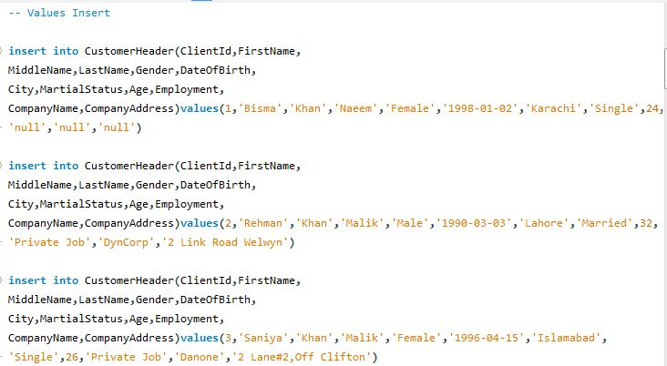

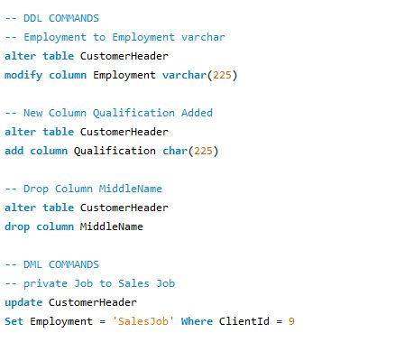

**Table Screenshot**

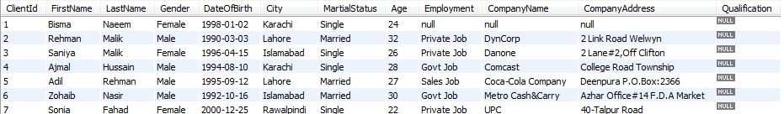

**CustomerDetails Table**

**Queries Screenshots**

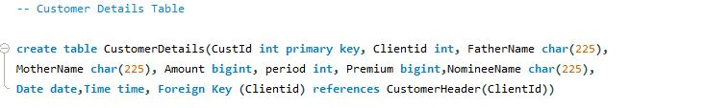

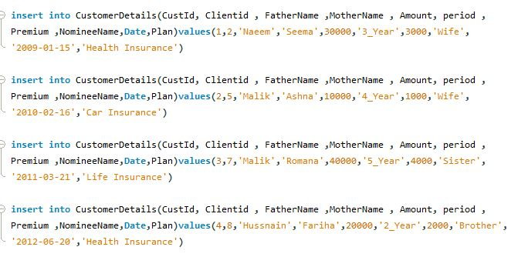

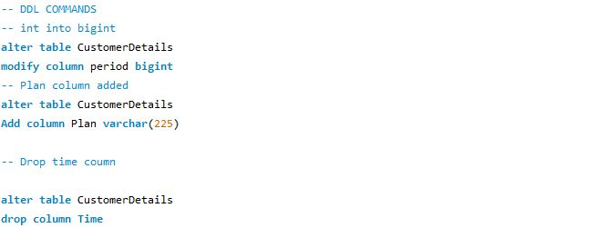

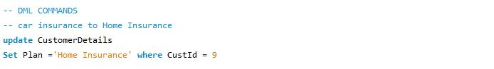

**Table Screenshot**

